EXECUTIVE SUMMARY

TABLE OF CONTENT.

1. Project Introduction
2. Data Review.
3. Data Extraction.
4. Data Cleaning and Preparation.
5. Data Visualization.
6. Summary and recommendation.

Project Introduction

In this project I will be examining a dataset that contains the sales of bicycle parts across 6 countries which includes United states, Australia, Canada, United Kingdom, Germany and France. I will use python as my analysis tool and I hosted my code on Jupyter notebook. In the course of this, I will collect data, carry out data wangling, perform analysis and visualizations to better understand our dataset, create insights and make recommendation.

Data Review

The Bicycle sales dataset contains 113,036 rows and 18 columns. The content of the dataset includes parts by parts of of bicycle sold across all the 6 countries.

The columns include

Water Date **–** The date format on our date column is DD-MM-YYYY, represents the day,month and year.

Water Customer_Age – Represents the customers age.

Water Age_Group – Represents a number of people of similar age classed together

Water Customer_Gender – customer’s Gender was segmented into Male or Female

Water State – Represents territory where the products where traded

Water Product_Category – is a group of similar products that share similar characteristics.

Water Sub_Category – A reduced or subdivision of the Product Category

Water Product – it is the item for sale.

Water Ordered_Quantity – Quantity Of products a buyer is willing to pay for

Water Unit_Cost – Represents the total expenditure incurred to produce,store, and sell one unit of a product.

Water Unit_Price – Is the price for one item or product

Water Profit – financial Gain on product sales received when revenue surpasses cost and expenses

Water Cost – amount spent in the production of the products

Water Revenue – amount generated from the sales of products

I added the **Sales** column to assist us examine the sales of different products and how successful the product were.

Data Extraction.

I extracted my dataset from a github(<https://github.com/Python-World/python-mini-projects>) repository, I forked and pulled the dataset into my local repository so I could have a very good look at the columns in my machine then used a built in python function( pd.read_csv) to extract into my jupyter notebook. However, you can also use a web scraping method for this. Simply import pandas (import pandas as pd) and NumPy (import numpy as np) and then a simple syntax (df = pd.read_html(‘url of the dataset’)) can also get you the dataset.

Data Cleaning and Preparation.

After data extraction,

Saved the data in DataFrame using pd.DataFrame(“dataset”) and used dataset.shape to know the number of



rows and columns contained in my dataframe

Water Checked for null values across using ‘dataset’.isnull().sum()

Viewed the details of the dataset using dataset.head()—this automatically shows you the 5 rows of your dataset.



Water Also used .info(), .dtypes and .describe to know the details, the data type and the statistical analysis of our dataset respectively.

Water I added **SALES** column by multiplying the Order_Quantity column by the Unit price.

Data Visualization.

Here I used charts and plots to create Visuals so as to have a clear understanding of our dataset

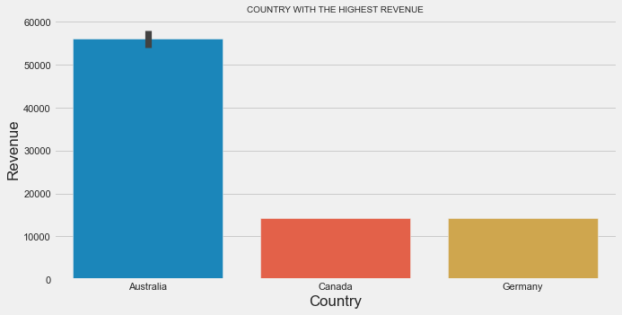

Australia made the highest revenue across all the countries followed immediately by Germany and Canada.

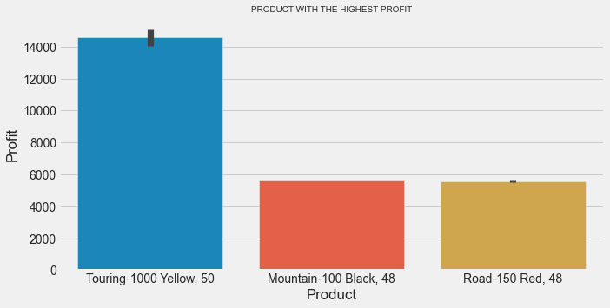

# Insights

Touring-1000 Yellow,50 , Mountain-100 Black, 48 and Road 150 Red,8 made the most Profit across all product line judging from this I can strongly recommend this product for investment.

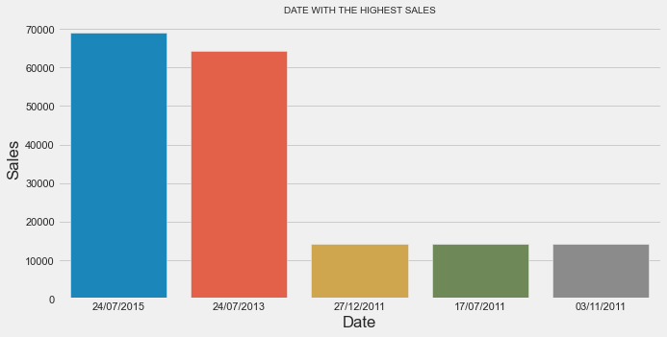

# Insights

The largest sales were made on the 24th of July 2015. I also noticed a high sale relationship trend on July, there was high

sales on July as seen on the bar plot.

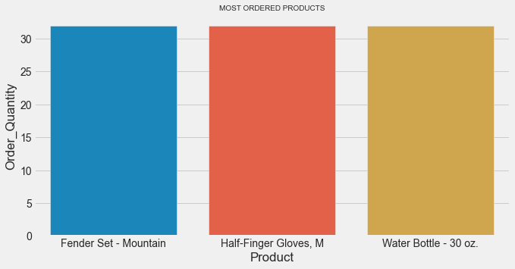

# Insights

As seen from the barplot, Fender Set-Mountain, Half-Finger,M and Water Bottle-30 oz were the most

ordered Product across all the Products.

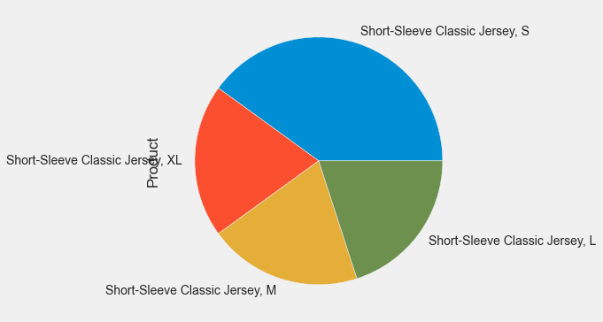

# Insights

These Products short-sleeve classic jersey,M , Short-sleeve classic jersey,L , short-sleeve classic jersey,XL , and short-sleeve classic,S , jersey made the lowest profits among all product.

From this we can simply say that people had little or no interest in this product.

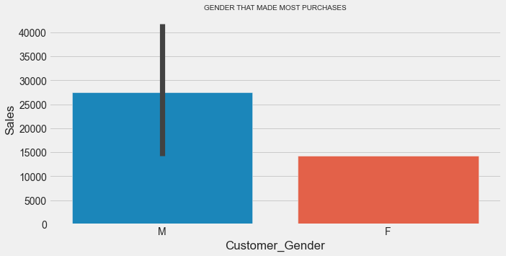

# Insights

Male gender made most Purchase as compared to the female gender, this simple means that mens

products was more purchased than that of women.

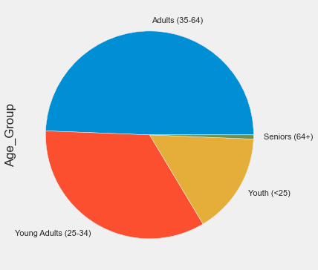

# Insights

1) Adults (35-64) age group visited the shops more than any other any other age Group strongly followed by Young Adults(25-34)

2) Senior (64+) age group had the lowest turn up with regards

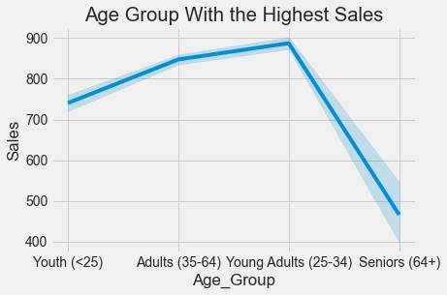

# Insights

CLearly from the line plot we can notice that people from the age range of 25-34(Young Adults)

made more purchase than any other age bracket, followed by Adults (35-64).

Now this simple means that this same age brackets also made the highest profit and the highest

revenue as well.

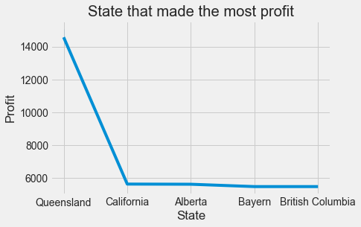

# Insights

Queensland is the state that made the highest profit in the sales of products when compared across all states.

Summary And Recommendations.

1) From our plot barplot, Australia, Canada and Germany made the highest sales which resulted to the highest revenue across all country.

2) Touring-1000 Yellow,50 , Mountain-100 Black, 48 and Road 150 Red,8 generated the most revenue across all product then we can conclude that investing in this three products in the stated Countries above will obviously lead to high return.

3) Fender Set-Mountain, Half-Finger,M and Water Bottle-30 were the most ordered product across all product judging from this it simply means that there was high demand for this products and is definitely going to lead to high sales and revenue.

4) short-sleeve classic jersey,M , Short-sleeve classic jersey,L , short-sleeve classic jersey,XL , and short-sleeve classic,S made the lowest sales across all products this however shows that buyers had little or no interest in this products.

5) Men Product were bought more than that of the women. With this in consideration we can confidently recommend that investing more in Men product will definitely lead to much more sales.

**The end.**